My English Hub

# 📘 My English Hub

### B2 English – Speak naturally, think clearly

### 👋 You are welcome here

This booklet is designed to help you refine your English and sound more natural in everyday and professional conversations. You'll explore idiomatic expressions, connectors, advanced structures, and strategies for expressing your opinion clearly and persuasively.

👉 Use English fluently and confidently in real-world discussions, both formal and informal.

### 🔹 Useful idioms

Here's a full **set of 10 idioms**, followed by a **mini practice** (choose the correct idiom) for each.

1. **I’m over the moon** – I’m very happy
2. **It’s not my cup of tea** – I don’t like it
3. **Let’s call it a day** – Let’s stop working for now
4. **I’m in hot water** – I’m in trouble
5. **To be on the same page** – To agree or understand each other
6. **Break a leg** – Good luck (especially before a performance)
7. **Spill the beans** – Reveal a secret
8. **Cost an arm and a leg** – Be very expensive
9. **Under the weather** – Feeling sick
10. **Hit the nail on the head** – Be exactly right

**🔸 Mini Practice: Choose the correct idiom**

**1.** “I just got the job I wanted!”   
→ I’m ____!  
a) over the moon  
b) under the weather  
c) calling it a day

**2.** “I really didn’t enjoy the concert.”  
→ It’s not ____.  
a) my cup of tea  
b) my slice of cake  
c) my happy hour

**3.** “We’ve worked hard enough. Time to rest.”  
→ Let’s ____.  
a) spill the beans  
b) call it a day  
c) get in hot water

**4.** “I forgot my boss’s birthday. I’m ____.”   
a) over the moon  
b) in hot water  
c) on the same page

**5.** “We totally agree on this.”  
→ We’re ____.  
a) in hot soup  
b) on the same page  
c) calling it a day

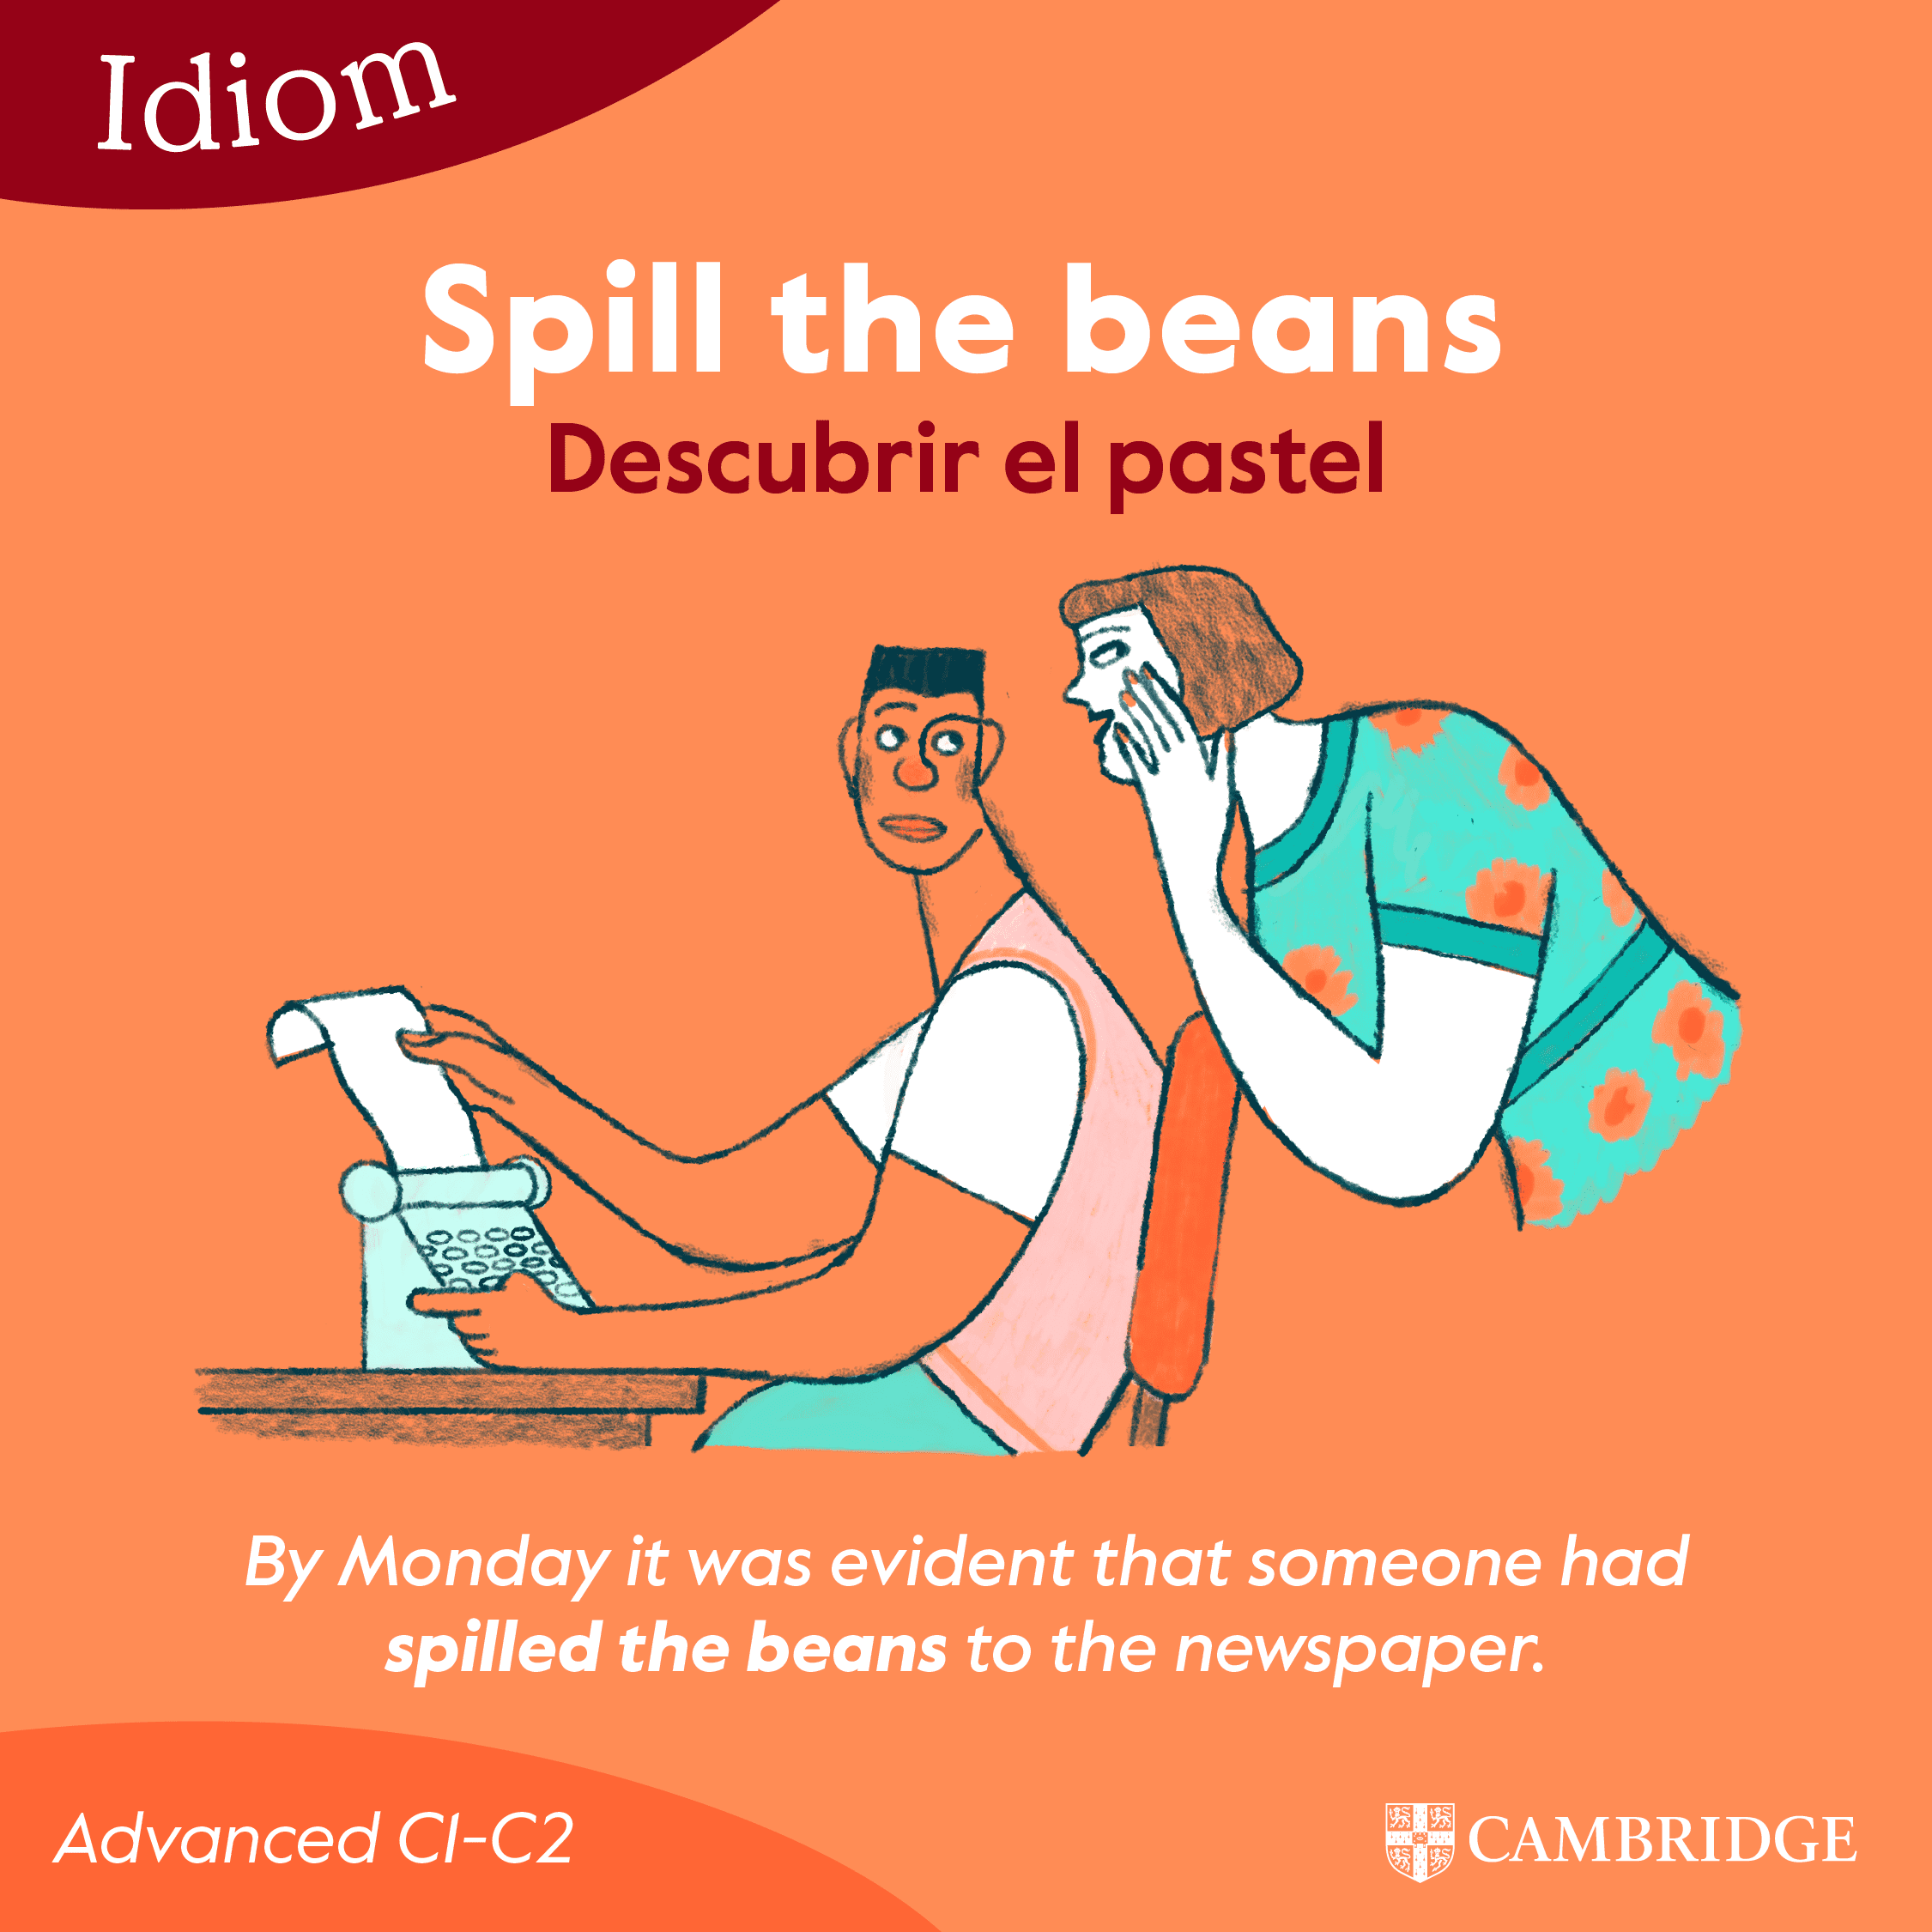**6.** “You have a big audition? ____!”  
a) Break a toe  
b) Break a leg  
c) Break it up

**7.** “He finally told us the secret!”  
→ He ____.  
a) called it a day  
b) hit the nail  
c) spilled the beans

**8.** “That designer bag was amazing, but it ____.”  
a) cost an arm and a leg  
b) broke a leg  
c) was my cup of tea

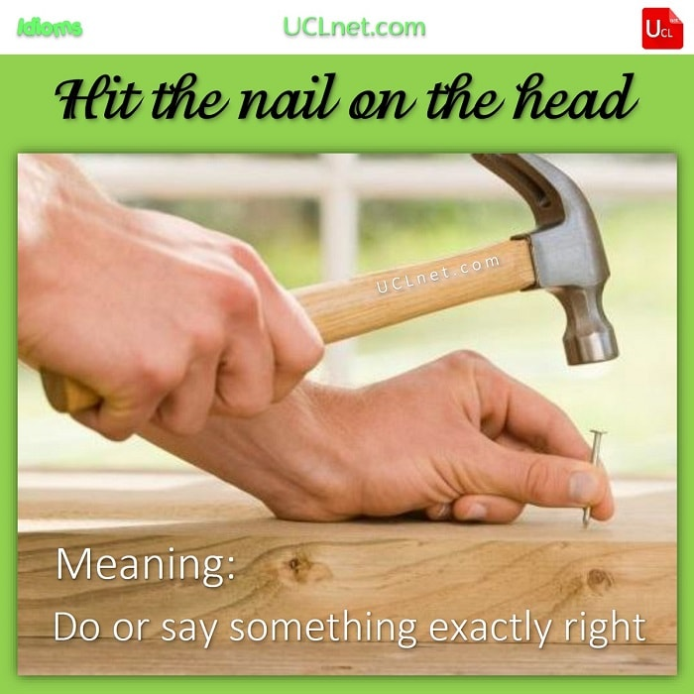**9.** “I’m staying in today, got the flu. I feel ____.“  
a) over the moon  
b) under the weather  
c) on the same road

**10.** “That’s exactly the solution!”  
→ You ____.  
a) spilled the coffee  
b) hit the nail on the head   
c) broke a leg

## 🗣️ **Expressing opinions and arguments**

### 🔹 Key phrases

* From my point of view…
* I see your point, but…
* That’s a fair argument, however…
* What I mean is…
* To be honest, I believe…

### 🔸 Speaking

**Debate with a partner:**  
Should companies allow remote work permanently?  
→ Use 3 of the phrases above in your answer.

## 💬 **Polishing your communication**

### 🔹 Natural-sounding alternatives

* “I don’t know” → I’m not quite sure / That’s a tough one
* “I agree” → Absolutely / I couldn’t agree more
* “I don’t think so” → I’m not convinced / I doubt that

### 🔸 Dialogue example

👤 A: Do you think learning English is easier today?  
👤 B: I’m not quite sure. On the one hand, we have more resources. On the other hand, we get distracted more easily.  
👤 A: That’s true. I couldn’t agree more.

## 🎧 Interactive Practice

➡️ Click the links below to review and practice online:

1. [Idioms – Wordwall](https://wordwall.net/resource/3238821/idioms)
2. [Giving Opinions](https://wordwall.net/resource/6046619/giving-opinions)

## ✅ Self-Check

**Can you now…**  
☐ Use 5 idioms naturally?  
☐ Express and defend an opinion?  
☐ Sound more natural when speaking?

**Quick review quiz:**

1. “We need to stop for today.”  
   → Let’s ____.  
   a) call it a day  
   b) turn on the lights  
   c) wrap the story
2. “I don’t fully agree with you.”  
   →  
   a) We are not on the same page here.  
   b) I think it is correct.  
   c) You are wrong

## 📲 Keep growing with us

👉 Ask us about the C1 Program  
👉 Join live conversation sessions  
👉 My English Hub – where real English happens